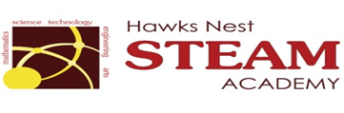School Counseling Program Newsletter
Shandrai Silva, School Counselor | October 2016
Counselor Message  Happy Fall! We are off to a great start at Hawks Nest STEAM Academy. Students have been engaged in a lot of activities: learning, exploring, problem-solving and creating. We participated in International Dot Day, International Peace Day and the Cardboard Challenge/World Day of Play. Our Make Your Mark service project was a huge success. Together, we collected almost 600 toothbrushes for the Ronald McDonald House of Charlotte.  We’re looking forward to another  great month at Hawks Nest!  __________________________  How to see the school counselor  Classroom guidance classes are weekly based on grade level specials schedule. Small group counseling and individual counseling by self -referral, parent referral, teacher referral, administrator referral or counselor initiated.  Contact School Counselor at 704-866-8467or sosilva@gaston.k12.nc.us.  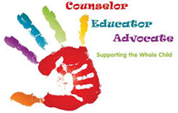 | Home of the Hawks    Bullying Prevention Month  This month we focus on continuing to promote a culture of kindness and respect. Unity Day is Wednesday, October 19th- wear orange to show  your commitment to ending bullying everywhere.  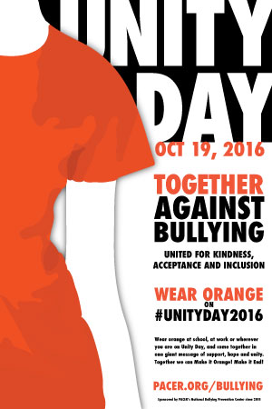  Red RibbonWeek  October 24-28, 2016  During this week, our focus is  on healthy living through a  several activities such as  classroom guidance lesson,  and Spirit Week.  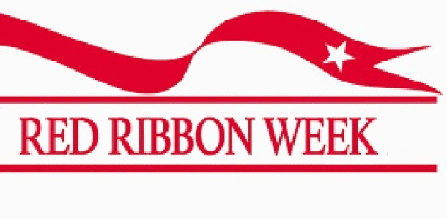 | Character Education  “We’re Soaring with Good Character”  ______________________________  The character trait of the month is Fairness. Fairness is taking turns, sharing, and listening to what others have to say; treating others respectfully.  ___________________________  Promoting Character Education  